**SUPPLY CHAIN MANAGEMENT**

MILESTONE 4

1.Create models based on your features and target variable. You have to create all the models that you come across till now. 2. Evaluate your model based on different evaluation parameters. 3. Build a conclusive visual report on evaluation parameter. 4. Give a brief and inferences about each and each model based on all evaluation parameter in dox format.

*1.Create models based on your features and target variable. You have to create all the models that you come across till now:*

We created 6 models .Linear Regression, Lasso, Ridge, Decision Tree , Random Forest and XGBoost.

*2. Evaluate your model based on different evaluation parameters :*

Since it’s a regression problem, here we are using Evaluation matrics like Mean Squared Error (MSE), Root Mean Squared Error (RMSE), Mean Absolute Error (MAE), and R-squared (coefficient of determination).

1.Mean Squared Error (MSE):

Measures the average squared difference between the predicted and actual values. A lower MSE is generally desirable, suggesting that the model's predictions are closer to the actual values.

2.Root Mean Squared Error (RMSE):

Square root of the MSE, provides a measure of the average magnitude of the errors. It is in the same units as the target variable.

3.Mean Absolute Error (MAE):

Measures the average absolute difference between the predicted and actual values. It represents the average magnitude of the errors, regardless of their direction. Similar to MSE, A lower MAE suggests that the model's predictions have less deviation from the actual values.

4. R-squared (R2):

Also known as the coefficient of determination, it indicates the proportion of the variance in the target variable that can be explained by the regression model. It ranges from 0 to 1, and higher values indicate better fit.

By calculating and examining these evaluation metrics for both the training and test sets, you can assess the performance of the regression model and understand how well it generalizes to unseen data.

* For the linear model ,we can infer that training and test values of MSE,RMSE,MAE are in acceptable range and not so much differed. Also training & test R2 is 94%.So its a generic model.
* In this Lasso model, we can infer that training and test values of MSE,RMSE,MAE are in acceptable range. Also train and test R2 value is 94% . Its also a generic model.
* With Ridge regressor, we can infer that training and test values of MSE,RMSE,MAE are in normal range. R2 values are 94% .It can e a generic Model.
* In Decision tree it can infer that training and test values of MSE,RMSE,MAE have comparable difference. The R2 values of training & testing gives 99 % & 98% .It can be a generic one.
* With Random Forest Here we can infer that training and test values of MSE, RMSE, MAE are in normal range . Both values gives a R2 value of99%.We can accept this model.
* Here we can infer that training and test values of MSE,RMSE,MAE are nearer. Also both R2 values are 99%.So it can be a generic model.

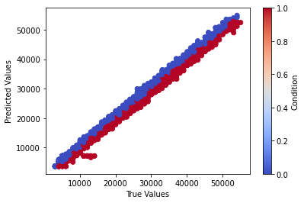

*This type of graph is shown, common for all the 6 models which gives the predicted and true values.*

*3. Build a conclusive visual report on evaluation parameter*:

* Training and testing MSE of the 6 models:

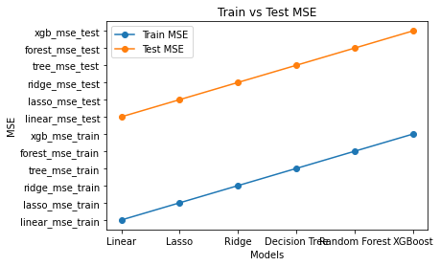

* Training and testing RMSE of the 6 models:

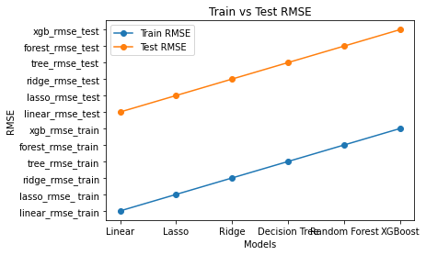

* Training and testing MAE of the 6 models :

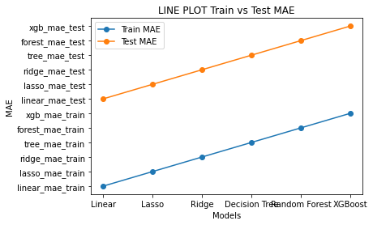

* Training and testing R2 of the 6 models:

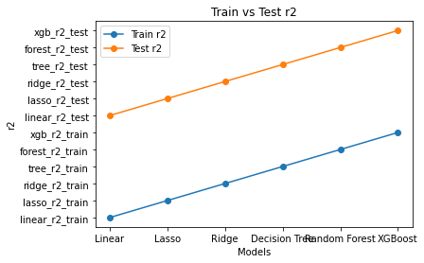

*4. Give a brief and inferences about each and each model based on all evaluation parameter in dox format.*

The train test accuracy of the models:

Linear Regression Train Accuracy: 0.9446044774081352

Linear Regression Test Accuracy: 0.9470057880311626

Lasso Train Accuracy: 0.9446078446469865

Lasso Test Accuracy: 0.9469714039985513

Ridge Train Accuracy: 0.9446042252855383

Ridge Test Accuracy: 0.9469252974717488

Decision Tree Train Accuracy: 0.9928973669360671

Decision Tree Test Accuracy: 0.9894574600809347

Random Forest Train Accuracy: 0.9927912426842906

Random Forest Test Accuracy: 0.9901512101688608

XGBoost Train Accuracy: 0.99237213620006

XGBoost Test Accuracy: 0.990822163633965

Cross Validation Score:

Linear Regression Mean CV Score: 0.9452732879417265

Lasso Mean CV Score: 0.9452694360420093

Ridge Mean CV Score: 0.9452668969264805

Decision Tree Mean CV Score: 0.9895435846544662

Random Forest Mean CV Score: 0.990093633046164

XGBoost Mean CV Score: 0.9908189778043196

The evaluation matrics values we examined in above steps are almost same as cross validation scores of 6 models. Also the test accuracy and cross validation mean score shows the same value. Mean score helps in comparing the performance of different models. So we can conclude that the model is a generic one.

:::THANK YOU:::